Name: Lyon Kee

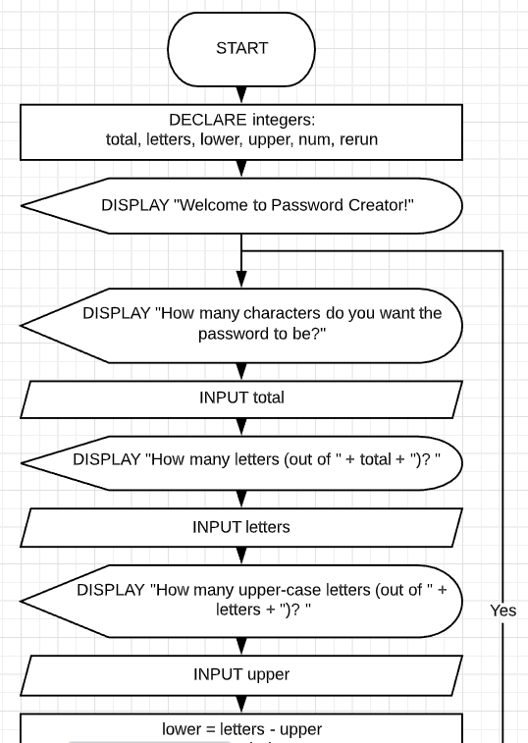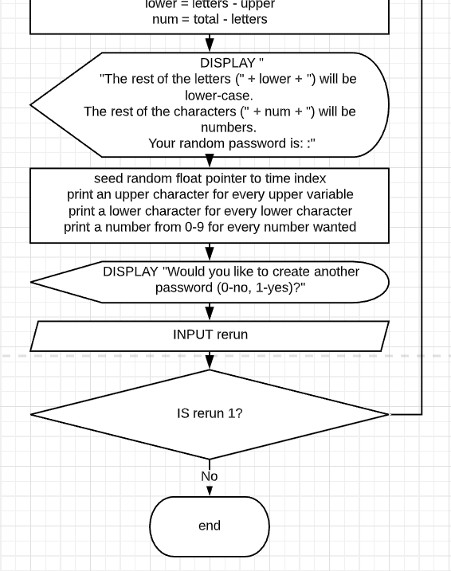

|  |  |  |
| --- | --- | --- |
| Test setting / prompt | User input | Expected result |
| How many characters do you want the password to be? | 25 | An output of 25 characters password is outputted |
| How many characters do you want the password to be? | 0 | An output of 25 characters password is outputted |
| How many letters (out of 25)? | 0 | It should output a password of all numbers |
| How many upper-case letters (out of 1)? | 1 | There will be a password of 1 upper case letter and 24 numbers |
| How many upper-case letters (out of 1)? | 0 | The password will have one lower case letter and 24 numbers |
| How many letters (out of 25)? | 25 | The password will contain all letters because we input the number of characters for the password to be 25 also. |